1. <http://localhost:8080/> - It will open file upload page

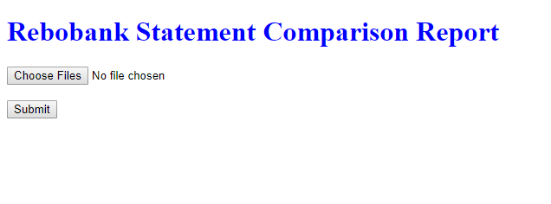

1. Select both xml and csv files

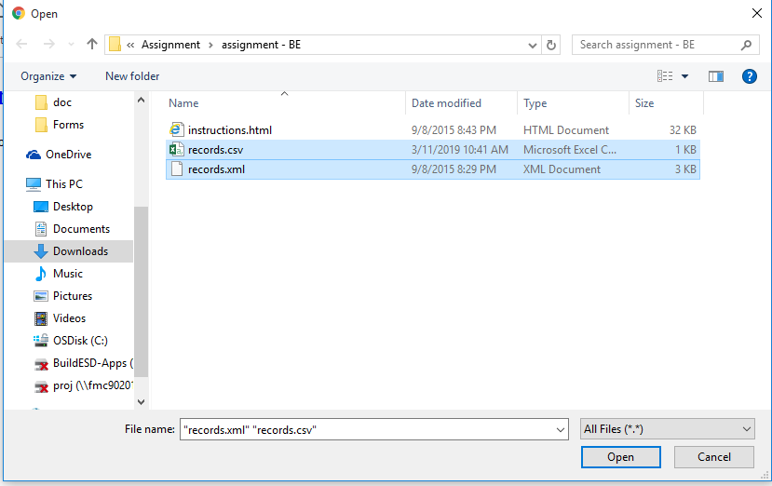

1. Two files selected, now submit

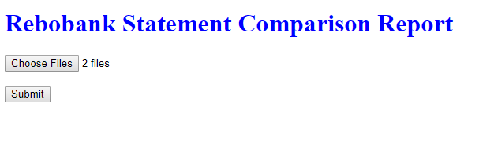

1. Failed reference report would be open

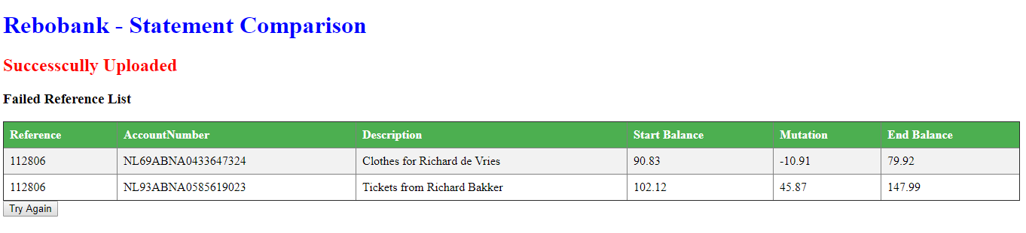

1. Test case and Validations have to do.